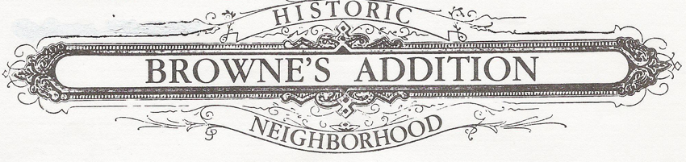

**August 5, 2015 Agenda**

**Browne’s Addition Neighborhood Council**

**And Steering Committee General Meeting**

**Northwest Museum of Arts & Culture**

**2316 W. First Ave**

**Gilkey Community Room 6:30 pm - 8:00 pm**

**Old Business**

(6:30) Welcome, Introductions, Announcements - Rick Biggerstaff

* Item for Vote - Approval of minutes
* Item for Information - Treasurer report – Julie Biggerstaff

(6:45) Items for Information –

* Friends of Coeur d'Alene Park – Julie Biggerstaff
* Friends of Historic Home Signs report – Louie Flores III
* Pedestrian, Transportation & Traffic (PeTT) Committee Report – Mike Harves
  1. - Use of city Red Light dollars discussion and straw vote
* Coeur d’Alene St. construction update – Karl Zacher
* Bus Shelter Update – Liz Marlin
* High Alcohol Free Zone movement – Eric Kramer
* Concert Series Update – Tim Finneran
* Neighborhood Cleanup – Amanda Hamilton

**New Business**

(7:30)

* Community Development Block Grant (CDBG). ***Item for vote*** – Rick Biggerstaff

**Neighborhood Discussion Forum**: High Alcohol Free Zone movement

* September 10, 7-8 pm at Browne’s Tavern

(8:00) Adjournment

**Join us at the Pacific Avenue Pizza after the meeting.**